**Exercise -1 ( The Glass House )**

Once King of Dholokpur has constructed a glass house for the prince. This glasshouse consists of 18 doors numbering 1, 2, 3 …18.

On one fine day when prince was playing hide & seek with his friends he went inside this glass house and was struggling to come out of the glass house since all the doors look similar. None other than the king know the solution to this complex problem.

Based on the location of the prince, the king announces the solution “The sum of the digits of a two digit number, would lead you out of the glass house”

**Solution : Write a generic program which accepts a two digit number and find the exit door number of the glasshouse.**

***Algorithm-***

***Step 1****: Initialize the variables for –*

*doorNumber – taken by user, integer type*

*doorKey =0 ,generated by the algorithm*

*temp variable .*

***step 2:*** *taking two digit number by the user – that is called doorNumber*

***step 3:*** *while doorNumber >0 then follow step 4 to step 6*

*otherwise goto step 2.*

***step4*** *: temp =doorNumber % 10 for taking last digit*

***step5*** *: doorKey = doorKey + temp;*

***step6 :*** *doorNumber =doorNumber / 10;*

***step7*** *: print – the exit door number*

**Flow Chart**

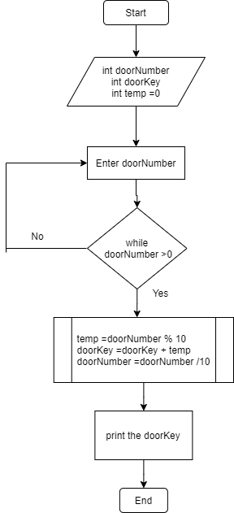

***Exercise -2 ( Traffic Congestion- Even Odd rule )***

*Delhi government has introduced a rule to avoid traffic congestion on roads.*

*The rule governs the cars plying on the roads on any given day depending on the current day of the month.*

*Cars with even registration numbers can ply if the current day is even, else it would be cars with odd registration numbers.*

*Added to this the Digital message board should display either of the following messages depending on the day of the month, ' Cars with Odd registration numbers are permitted today' or 'Cars with Even registration numbers are permitted today‘.*

*Date value should be between 1 to 31 . Or else should show error message “Invalid Input”*

***Solution : Write a program to accept the day value as input and display appropriate message as output based on the day .***

***Algorithm-***

Step1 : Initialize variables – int date (contain any value from 1 to 31 )

Int carNumber;

Step2 : Enter date & car number ;

Step 3: if date >1 and date < 31 then

if date % 2 ==0 then

Print – even cars can run

Otherwise – odd cars can run

Else – goto step 2;

Step 4: finish

***Flow Chart***

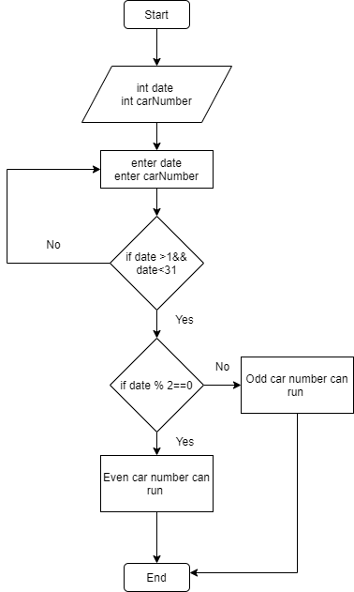

**Exercise -3 (Choosing the Best Horse)**

A king has three horses and wants to go for hunting on the horse. It was a difficult choice, as the three horses were equally good. He came up with a strategy to choose the horse.

The horse that weighs the most will be the one that goes with him for hunting.  
He has approached you to design a program to automate this process. Can you help him?

Solution : Write a program to accept the weights of 3 horses and display the weight of the horse with maximum weight. If to horses are of same weight and are best then should show message ,”Entered weights are not distinct values”

***Algorithm***

Step1 : initialize variables –

Int noOfHorses ,maxWeight;

Step2 : enter number of horses you have

Step 3: make a array for storing the weight of horses you have

Step 4: now check the maximum weight of horse

Step 5: go with maximum weighted height and print as well

Step 6 : finish

***Flow Chart***

